



**EM Vibration Test Report**

Kyushu Institute of Technology

Laboratory of Spacecraft Environment Interaction Engineering



Revision History

|  |  |  |  |
| --- | --- | --- | --- |
| Version | Date | Writer | Annotations |
| V1.0 | 2019/10/05 | Yigit | First Draft |
|  |  |  |  |
|  |  |  |  |

Contents

**[1](#_Toc21302290)****[Introduction](#_Toc21302290)** [3](#_Toc21302290)

[1.1 Application 3](#_Toc21302291)

[1.2 Applicable Documents 3](#_Toc21302292)

[1.3 Purpose 3](#_Toc21302293)

**[2](#_Toc21302294)****[Test Date](#_Toc21302294)** [4](#_Toc21302294)

[2.1 Period 4](#_Toc21302295)

[2.2 Test Facility 4](#_Toc21302296)

**[3](#_Toc21302297)****[Preparation](#_Toc21302297)** [4](#_Toc21302297)

[3.1 Test Equipment 4](#_Toc21302298)

[3.2 Test Tools 4](#_Toc21302299)

[3.3 Measurement Instrument 5](#_Toc21302300)

**[4](#_Toc21302301)****[Test Method](#_Toc21302301)** [6](#_Toc21302301)

[4.1 Test Article 6](#_Toc21302302)

[4.2 General Condition 7](#_Toc21302303)

[4.3 Test Condition 7](#_Toc21302304)

[4.4 Test flow 10](#_Toc21302305)

[4.5 Test Configuration 11](#_Toc21302306)

[4.6 Measurement Configuration 14](#_Toc21302307)

[4.7 Organization 15](#_Toc21302308)

**[5](#_Toc21302309)****[Precaution](#_Toc21302309)** [15](#_Toc21302309)

[5.1 Precaution during test 15](#_Toc21302310)

[5.2 Safety Control Matters 15](#_Toc21302311)

**[6](#_Toc21302312)****[Emergency Contact System](#_Toc21302312)** [15](#_Toc21302312)

**[7](#_Toc21302313)****[Acquired Data](#_Toc21302313)** [15](#_Toc21302313)

[7.1 Results of Z axis 16](#_Toc21302314)

[7.2 Results of X axis 19](#_Toc21302315)

[7.3 Results of Y axis 22](#_Toc21302316)

**[8](#_Toc21302317)****[Summary of Results & Conclusion](#_Toc21302317)** [25](#_Toc21302317)

# **Introduction**

## Application

Vibration test demonstrates the ability of a test article to withstand the vibrations environment imposed. The aim of the test is to demonstrate that the test article can withstand mechanical vibration when excited with acceleration levels induced by launch vehicles including HTV, SpX and Orbital Cygnus.

## Applicable Documents

* 1. JX-ESPC-101133C　‘JEM Payload Accommodation Handbook Vol.8 Small Satellite Deployment Interface Control Document’, November 2018.
  2. Torque Chart ‘Maryland Metrics Torque Chart’, Retrieved May, 2016. Link: <https://mdmetric.com/tech/torqcht1a.pdf>

## Purpose

The purpose of this test is to evaluate the impact of vibration by launch vehicle on BIRDS-4 CubeSat structure. The test objective is as follows,

1. Deformation in the Main Structure: No deformation shall be observed in the inspections on the main frame before and after the test.
2. Shift in Natural Frequency: A significant shift in natural frequency indicates *workmanship failure* (loose components on/in the structure). Any broken parts in the primary structure shall be judged as a *failure in design.* The primary natural frequency shall be at least 100 Hz in X, Y, Z axes.
3. Torque Mark Shift: When observed visually, there should be no shift in torque marks on the screws on the test article after each test. Any shift in torque mark shows a *workmanship failure* in setting the required torque before testing
4. Fracture Critical Parts:
   * All external fasteners and fasteners holding the main structure shall not be loose after vibration.
   * Glass components (including solar cells and camera lens) shall not be broken after vibration.
5. Deployable Components:
6. Satellite Function

Satellite functional test shall be conducted before and after vibration tests. Satellite should function the same after the vibration test as before the test.

# **Test Date**

## Period

2019/10/03-2019/10/04

## Test Facility

Center for Nanosatellite Testing (CeNT)

Laboratory of Spacecraft Environment Interaction Engineering

Kyushu Institute of Technology

1-1 Sensui, Tobata, Kitakyushu, 804-8550 Fukuoka, Japan

# **Preparation**

## Test Equipment

The test equipment used by this test is indicated in Table 3.1 1.

**Table 3.1‑1　Test equipment**

|  |  |  |  |  |
| --- | --- | --- | --- | --- |
| No. | Name | Type | Maximum excitation force  Frequency range | Owner |
| 1 | Vibration test machine | F-35000BD/LA36AP(made by EMIC) | 28kN  5Hz～2200Hz | Kyushu Institute of Technology |

## Test Tools

The test jig and tool used by this test are indicated in Table 3.2-1 and 3.2-2, respectively.

**Table 3.2‑1　Test jig**

|  |  |  |  |
| --- | --- | --- | --- |
| No. | Name | Quantity | Note |
| 1 | Jig | 1 | KyuTech |
| 2 | Test POD | 1 | KyuTech |
| 3 | 1U Dummy | 2 | KyuTech |

**Table 3.2‑2　Tools**

|  |  |  |  |  |  |
| --- | --- | --- | --- | --- | --- |
| No. | Name | Type | Manufacture | Quantity | Note |
| 1 | Wrench torque | 30-140Nm | Tohnichi | 1 |  |
| 2 | Wrench torque | 2-10Nm | Tohnichi | 1 |  |
| 3 | Wrench driver | 0.2-1.2Nm | Tohnichi | 1 |  |
| 4 | Kapton tape | - | - | 1 |  |
| 5 | Tape | - | - | 1 |  |
| 6 | Instant glue | - | - | 1 |  |
| 7 | Alcohol | Isopropyl | - | 1 |  |
| 8 | Paper cloth | JK wiper | - | 1 |  |
| 9 | Pen | - | - | 1 |  |

## Measurement Instrument

The measurement instrument used by this test is indicated in Table 3.3-1.

**Table 3.3‑1　Measurement instrument**

|  |  |  |  |  |  |
| --- | --- | --- | --- | --- | --- |
| No. | Name | Type | Manufacture | Quantity | Note |
| 1 | Accelerometer | 731-B | EMIC | 7 | For controlling and monitoring |
| 2 | Accelerometer | 2222C | Endevco | 6 | For monitoring |
| 3 | Charge Amp. | 4035 | SHOWA | 2 |  |
| 4 | DAQ system | 9215 | National Instrument | 1 |  |
| 5 | Analysis device | PC | - | 1 |  |
| 6 | Coaxial cable for accelerometer | - | - | 11 |  |
| 7 | Coaxial cable for connecting DAQ and Amp | - | - | 11 |  |

# **Test Method**

## Test Article

The test article is BIRDS-4 (EM). The test sample is the one that installed NARSSCube-1 in a test POD.

The outside drawing and the coordinates system of the test article and the test sample are shown in Figure 4.1‑1 and Figure 4.1‑2.

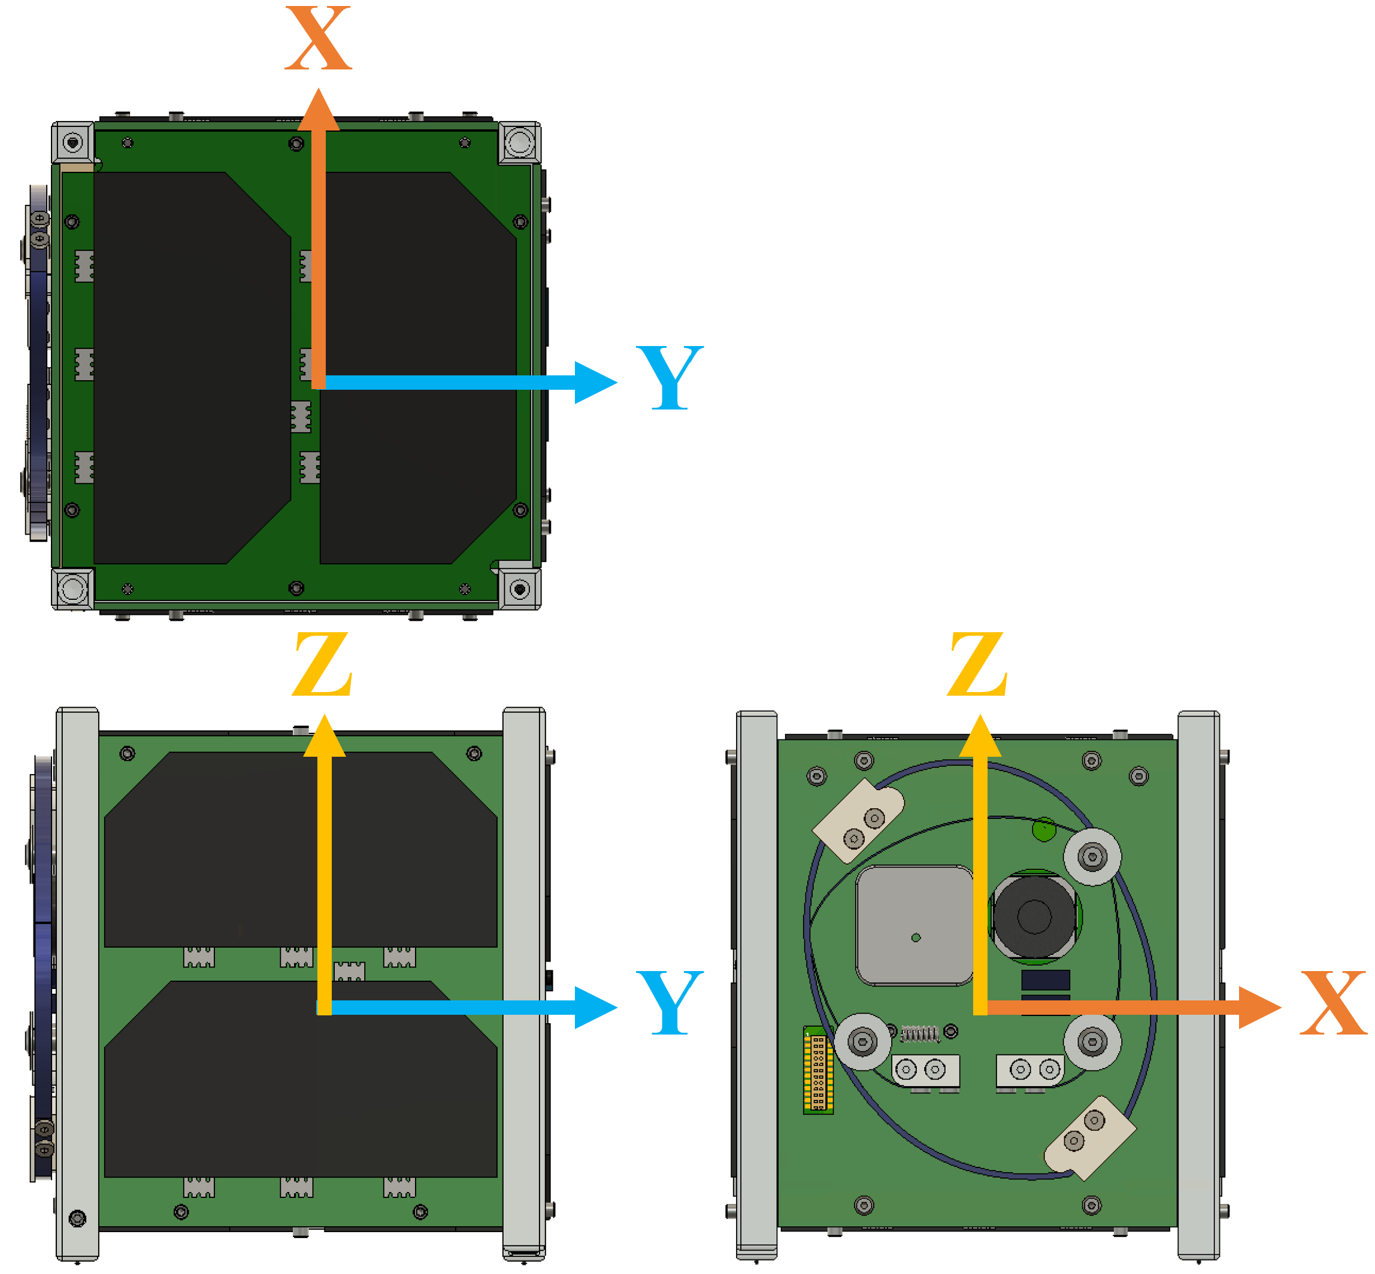

**Figure 4.1‑1 Outside drawing and coordinates system of test article**



X

Y

**Figure 4.1‑2 Coordinates system of test sample**

## General Condition

General conditions are as follows.

Temperature : 15°C - 30 °C

Humidity : 30 – 60 %

Atmosphere : Atmospheric pressure

## Test Condition

1. Random Vibration

The test condition of random vibration is indicated in Table 4.3‑1 and Figure 4.3-1. This Profile is as shown in Figure 4.3-2 derived from maximum PSD values of HTV, SpX Dragon, NG Cygnus launch vehicles as shown in Table 4.3-2.



**Figure 4.3-1 Random vibration profile (QT level)**

**Table 4.3‑1　Random vibration (QT level)**

|  |  |
| --- | --- |
| Envelope | |
| **Frequency**  **(Hz)** | **PSD**  **(G2/Hz)** |
| 20 | 0.030 |
| 25.6 | 0.054 |
| 30 | 0.16 |
| 80 | 0.16 |
| 133 | 0.08 |
| 500 | 0.08 |
| 2000 | 0.004 |
| **Overall** | 6.8 Grms |
| **Duration** | 60 sec/axis |



**Figure 4.3-2 AT random vibration profiles for HTV, SpX Dragon and NG Cygnus**

**Table 4.3-2 Random vibration (AT level) of each launch vehicle**

|  |  |  |  |  |  |  |  |
| --- | --- | --- | --- | --- | --- | --- | --- |
| **HTV** | | **SpX Dragon** | | **Orbital Cygnus** | | **MWL** | |
| **Frequency**  **(Hz)** | **PSD**  **(G2/Hz)** | **Frequency**  **(Hz)** | **PSD**  **(G2/Hz)** | **Frequency**  **(Hz)** | **PSD**  **(G2/Hz)** | **Frequency**  **(Hz)** | **PSD**  **(G2/Hz)** |
| 20 | 0.005 | 20 | 0.015 | 20 | 0.005 | 20 | 0.01 |
| 50 | 0.02 | 25.6 | 0.027 | 70 | 0.04 | 80 | 0.04 |
| 120 | 0.031 | 30 | 0.08 | 200 | 0.04 | 500 | 0.04 |
| 230 | 0.031 | 80 | 0.08 | 2000 | 0.002 | 2000 | 0.01 |
| 1000 | 0.0045 | 2000 | 0.001 |  |  |  |  |
| 2000 | 0.0013 |  |  |  |  |  |  |
| **Overall** | 4.0 Grms | **Overall** | 4.06 Grms | **Overall** | 4.4 Grms | **Overall** | 6.8Grms |

1. Sine burst

The test condition of sine burst is indicated in Table 4.3-3.

**Table 4.3-3 Sine burst (QT level)**

|  |  |  |  |
| --- | --- | --- | --- |
| **SINE BURST (QT level)** | | | |
| **Direction** | **Freq. [Hz]** | **QT** | |
|  | **Number of waves\*1** | **Acceleration [G]** |
| Vertical axis (Y) | 10~40 | 10 or more | 22.63 |
| Horizontal axis (X, Z) | 10~40 | 22.63 |

\*1 sec includes 10 waves or more.

1. Modal survey

The test condition of modal survey is indicated in Table 4.3-3.

**Table 4.3‑3　Modal survey**

|  |  |  |  |  |
| --- | --- | --- | --- | --- |
|  | Frequency  (Hz) | PSD  (G2/Hz) | Acceleration  (Grms) | Time  (sec) |
| Each axis | 20～2000 | 0.000127 | 0.5 | 60 |

1. Test tolerance

Apart from modal survey, vibrations test tolerances are described below.

* 1. Quasi-static acceleration

・Acceleration: ±2%

* 1. Random vibrations

・Effective value: ±1.5dB

・Acceleration density: +3dB/-1dB

・Frequency: ±2% or above 1Hz

・Loading time: +10%/-0%

## Test flow

The test flow is shown in Figure 4.4‑1.

|  |  |  |  |  |  |  |  |  |  |  |
| --- | --- | --- | --- | --- | --- | --- | --- | --- | --- | --- |
|  | **01 Functional Test\*** |  |  |  |  |  |  |  |  |  |
|  | **↓** |  |  |  |  |  |  |  |  |  |
|  | **02 Preparation** |  |  |  | **08 Axis change** |  |  |  | **14 Axis change** |  |
|  | **↓** |  |  |  | **↓** |  |  |  | **↓** |  |
| **Z axis** | |  |  | **X axis** | |  |  | **Y axis** | |  |
|  | **03 Modal** |  | → |  | **09 Modal** |  | → |  | **15 Modal** |  |
|  | **↓** |  |  |  | **↓** |  |  |  | **↓** |  |
|  | **04 Random QT** |  |  |  | **10 Random QT** |  |  |  | **16 Random QT** |  |
|  | **↓** |  |  |  | **↓** |  |  |  | **↓** |  |
|  | **05 Modal** |  |  |  | **11 Modal** |  |  |  | **17 Modal** |  |
|  | **↓** |  |  |  | **↓** |  |  |  | **↓** |  |
|  | **06 Sine burst QT** |  |  |  | **12 Sine burst QT** |  |  |  | **18 Sine burst QT** |  |
|  | **↓** |  |  |  | **↓** |  |  |  | **↓** |  |
|  | **07 Modal** |  |  |  | **13 Modal** |  |  |  | **19 Modal** |  |
|  |  |  |  |  |  |  |  |  |  |  |
|  |  |  |  |  |  |  |  |  | **↓** |  |
|  |  |  |  |  |  |  |  |  | **20 Clean up** |  |
|  |  |  |  |  |  |  |  |  | **↓** |  |
|  |  |  |  |  |  |  |  |  | **21 Functional Test\*** |  |

**Figure 4.4‑1　Test flow**

## Test Configuration

Test configuration for each axis is shown in Figure 4.5‑1, Figure 4.5‑2 and Figure 4.5‑3. Axis definition shown is for the JSSOD coordinate system.

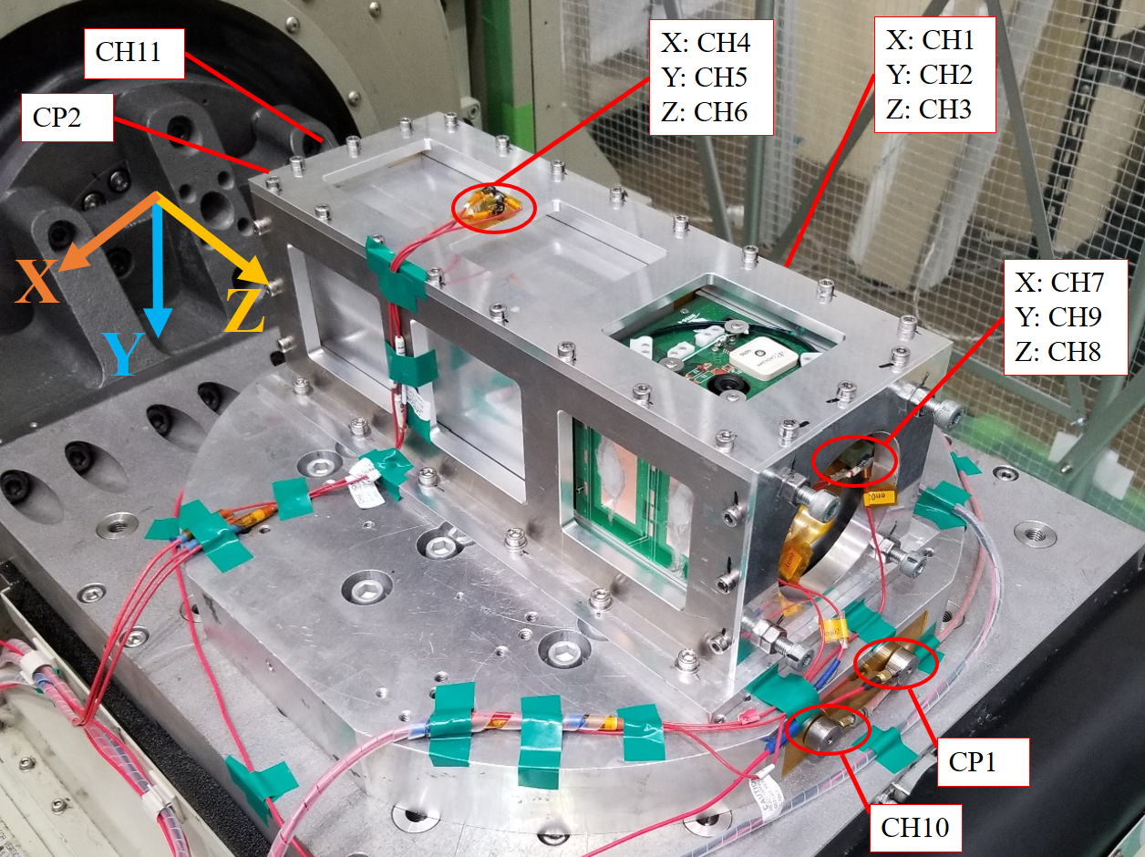

**Figure 4.5‑1　Test configuration (Z axis)**

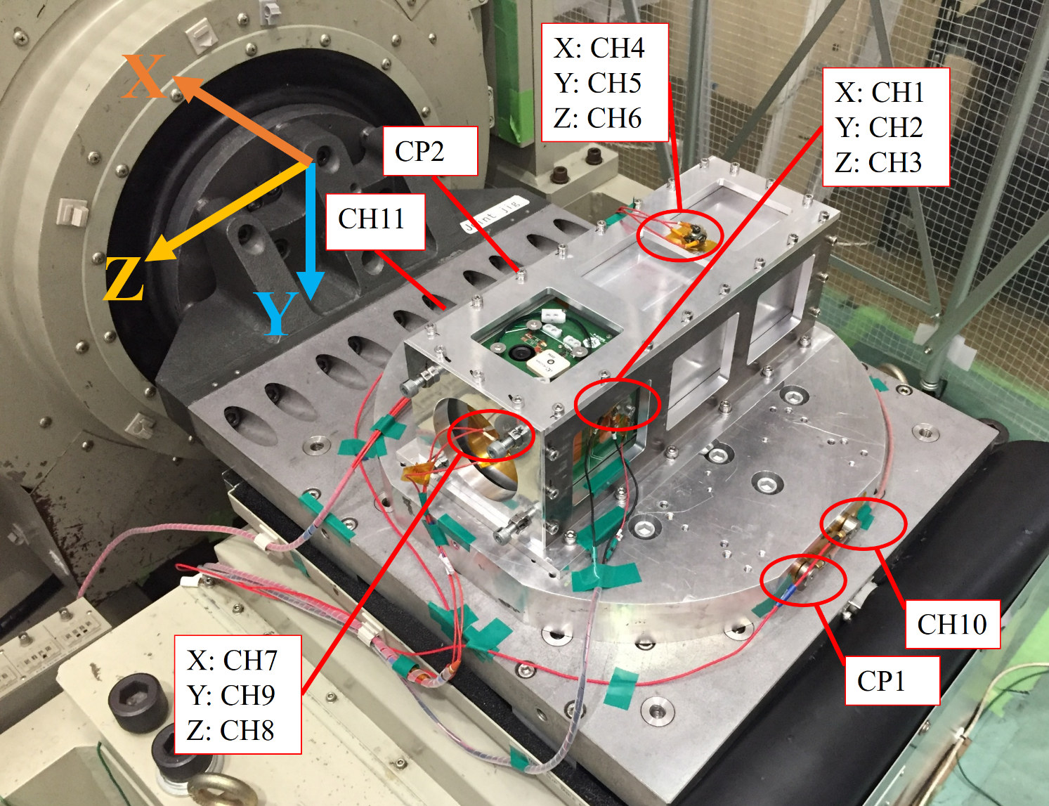

**Figure 4.5‑2　Test configuration (X axis)**

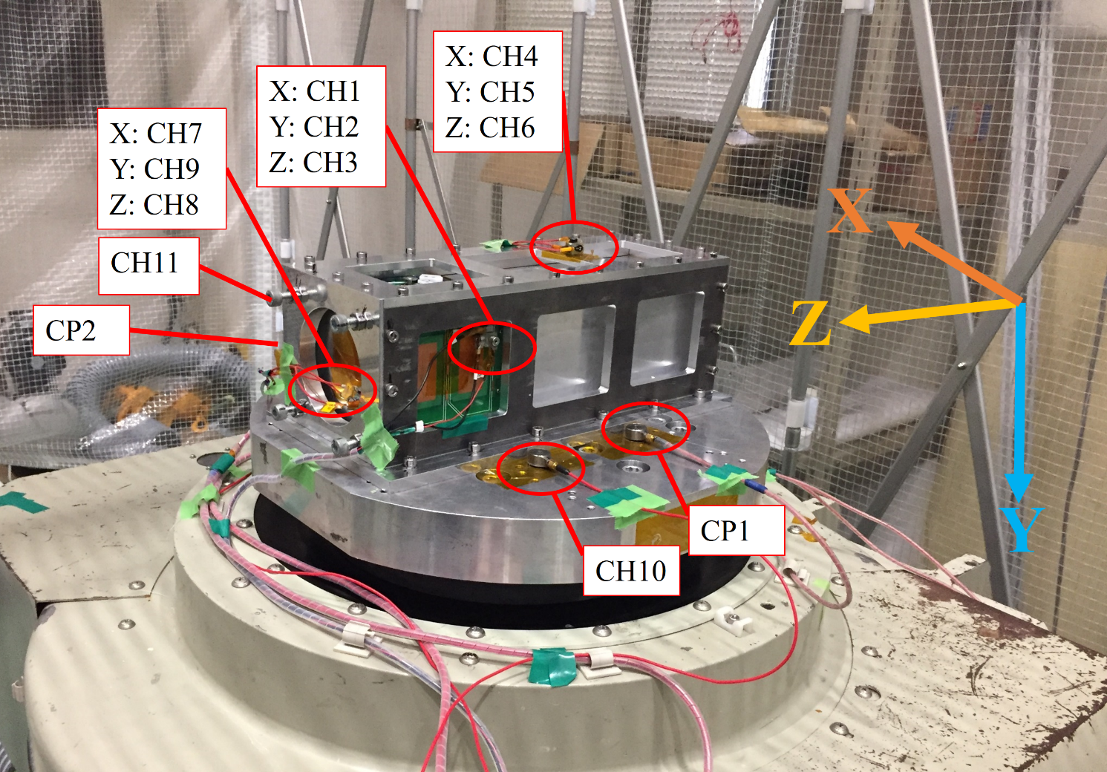

**Figure 4.5‑3　Test configuration (Y axis)**

The accelerometers position and channel number designation are indicated in Table 4.5-1.

**Table 4.5-1 Accelerometer position (\*CP: Control Probe)**

|  |  |  |  |  |
| --- | --- | --- | --- | --- |
| **Channel #** | **Axis** | **Mounting Position** | **Accelerometer** | **Model** |
| 1 | X | X Axis (-X panel) | EM46 | EMIC731-B |
| 2 | Y | EM47 |
| 3 | Z | EM48 |
| 4 | X | Y Axis (3U POD) | en11 | Endevco222C |
| 5 | Y | en10 |
| 6 | Z | en12 |
| 7 | X | Z Axis (3U POD) | en03 | Endevco222C |
| 8 | Z | en02 |
| 9 | Y | en01 |
| 10 | - | Jig | EM13 | EMIC731-B |
| 11 | - | EM14 |
| CP1\* | | EM15 |
| CP2\* | | EM12 |

**Table 4.5-2 Charge amplifier setting**

|  |  |  |
| --- | --- | --- |
| **Channel #** | **Accelerator** | **pC/G** |
| 1 | EM46 |  |
| 2 | EM47 |  |
| 3 | EM48 |  |
| 4 | en11 |  |
| 5 | en10 |  |
| 6 | en12 |  |
| 7 | en03 |  |
| 8 | en02 |  |
| 9 | en01 |  |
| 10 | EM13 |  |
| 11 | EM14 |  |

**Table 4.5-3 Torque list**



Table 4.5-4 shows the analysis software, shaker and AMP setting parameters to be used.

**Table 4.5-4 Setting parameters**

|  |  |  |  |  |
| --- | --- | --- | --- | --- |
| **Vibration test type** | | **Modal survey** | **Sine burst** | **Random** |
| Vibration Profile | | Random | Sine | Random |
| Vibration parameters | Test type | Modal | Sine Burst | Random |
| Frequency band [Hz]:  Min [Hz] | 20 | 5 | 20 |
| Frequency band [Hz]:  Max [Hz] | 2,000 | 100 | 2,000 |
| Setting of measuring:  Number of channels | 12 | 12 | 12 |
| Setting of measuring:  Measuring time [sec] | 50 | 30 | 110 |
| Setting of measuring:  Sampling rate [sample/sec] | 10,000 | 5,000 | 10,000 |
| Setting of analysis:  Number of FFT point | 8,192 | 2048 | 8,192 |
| Setting of analysis:  G/V | 10 | 10 | 31.6 |
| Monitor (OSC)  Display time (Sec) | 0.2 | 0.2 | 0.2 |
| Monitor (OSC)  Max value of voltage (V) | 2 | 7 | 7 |
| Vibration Machine control | Switch:  Sine - Random | Random | Sine/Shock | Random |
| External level | Half | Max | Max |

## Measurement Configuration

The measurement configuration of the monitor acceleration, the output signal processing and the inhibit confirmation are shown in Figure 4.6‑1.

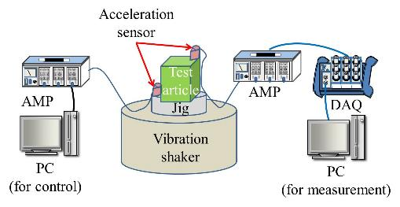

**Figure 4.6‑1　Measurement configuration**

## Organization

Test organization is shown in Figure 4.7‑1.

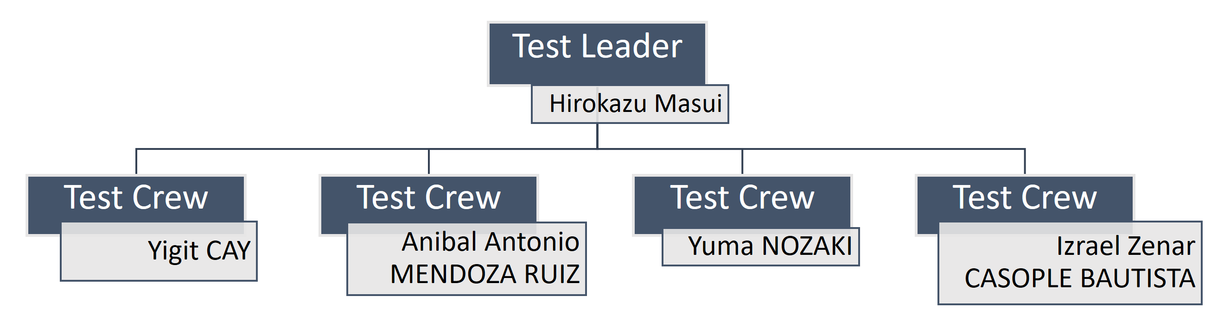

**Figure 4.7‑1　Test organization**

# **Precaution**

## Precaution during test

1. Test was performed by the instruction of the test leader.
2. The measurement instrument was used within the time required calibration.

## Safety Control Matters

1. To wear steel-toed shoes during testing.
2. Don’t enter in the excitation direction during testing.

# **Emergency Contact System**

In case of emergency, the chain of commands was shown in figure 6-1.

**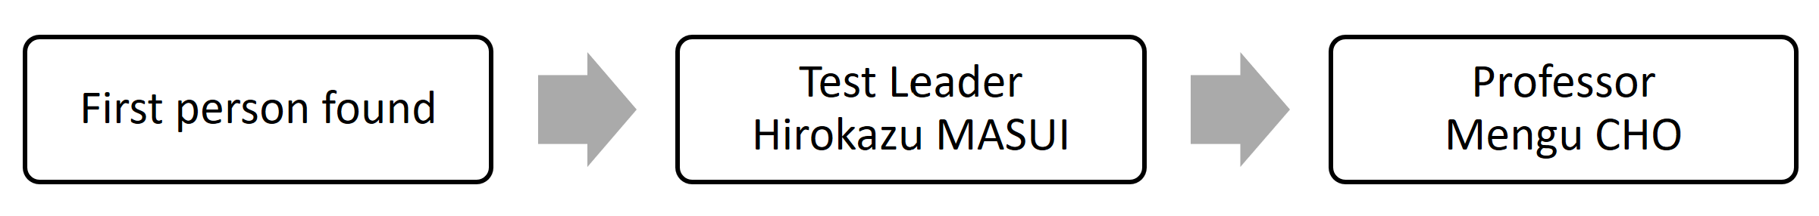**

**Figure 6-1　Emergency contact system**

# **Acquired Data**

This section provides the lecture of the accelerometers that were used during the vibration test.

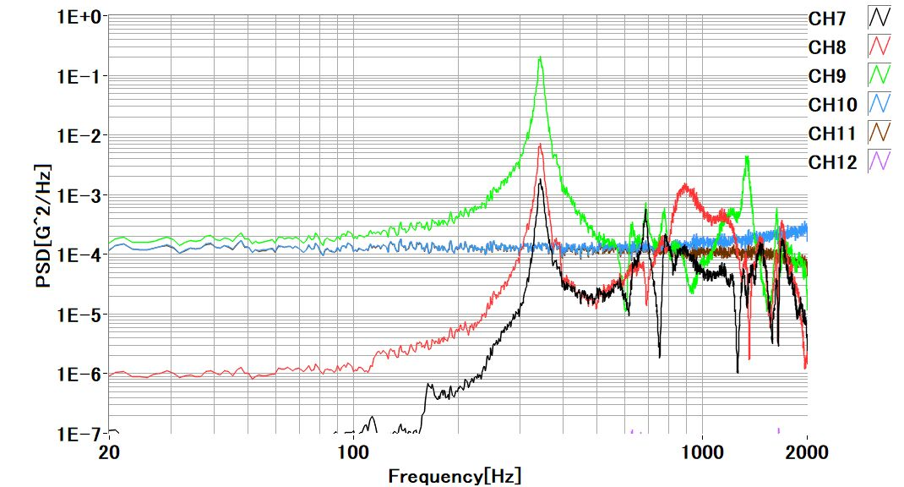

**Figure 7-1 Modal response of the jig (Channel No. 10-11, blue and brown, respectively)**

In the Figure 7-1 Modal response of the jig is possible to observe that the jig has a natural frequency out of the frequencies of interest of the test that are from 20 to 2000 Hz.

## Results of Z axis

Figures 7.1-1 and 7.1-2 shows the actual random vibration and sine burst profile excited PSC at the QT level in the Z axis. The Ch 2 and 3 are the control references.

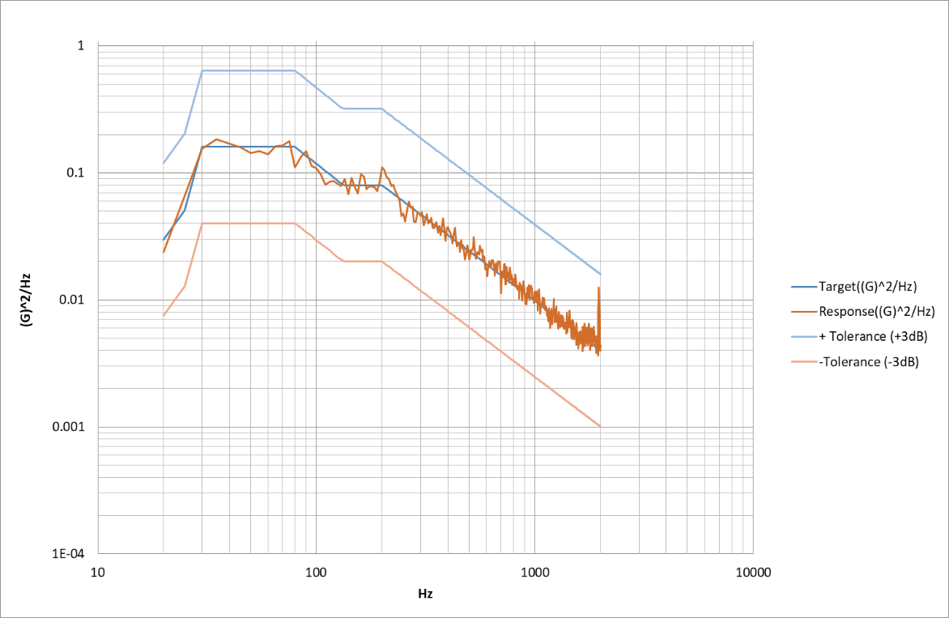

**Figure 7.1-****1 Random vibration input profile on the Z axis direction**

**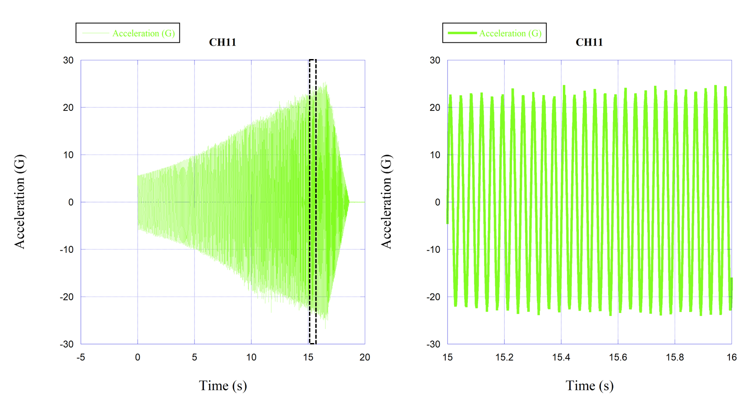**

**(a) (b)**

**Figure 7.1-2 (a) Sine burst input profile on the Z-axis direction and (b) 1 second window as wave form representative.**

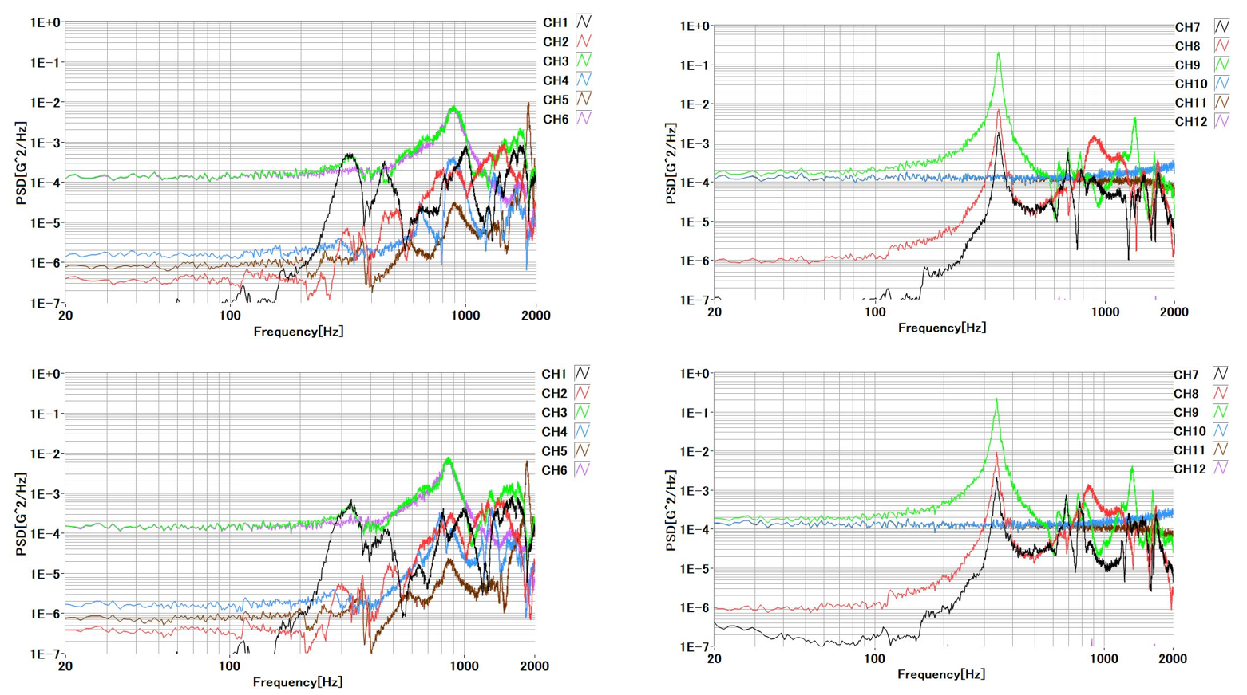

**Figure 7.1-3 Modal response before (top) and after (bottom) the random and sine burst test on Z axis.**

In Figure 7.1-3, the Ch3, Ch6 and Ch8 (green, pink and red, respectively) are the accelerometer on Z axis. No major shift in frequency was observed.

## Results of X axis

Figures 7.2-1 and 7.2-2 shows the actual random vibration and sine burst profile excited PSC at the QT level in the X axis. The Ch 2 and 3 are the control reference.

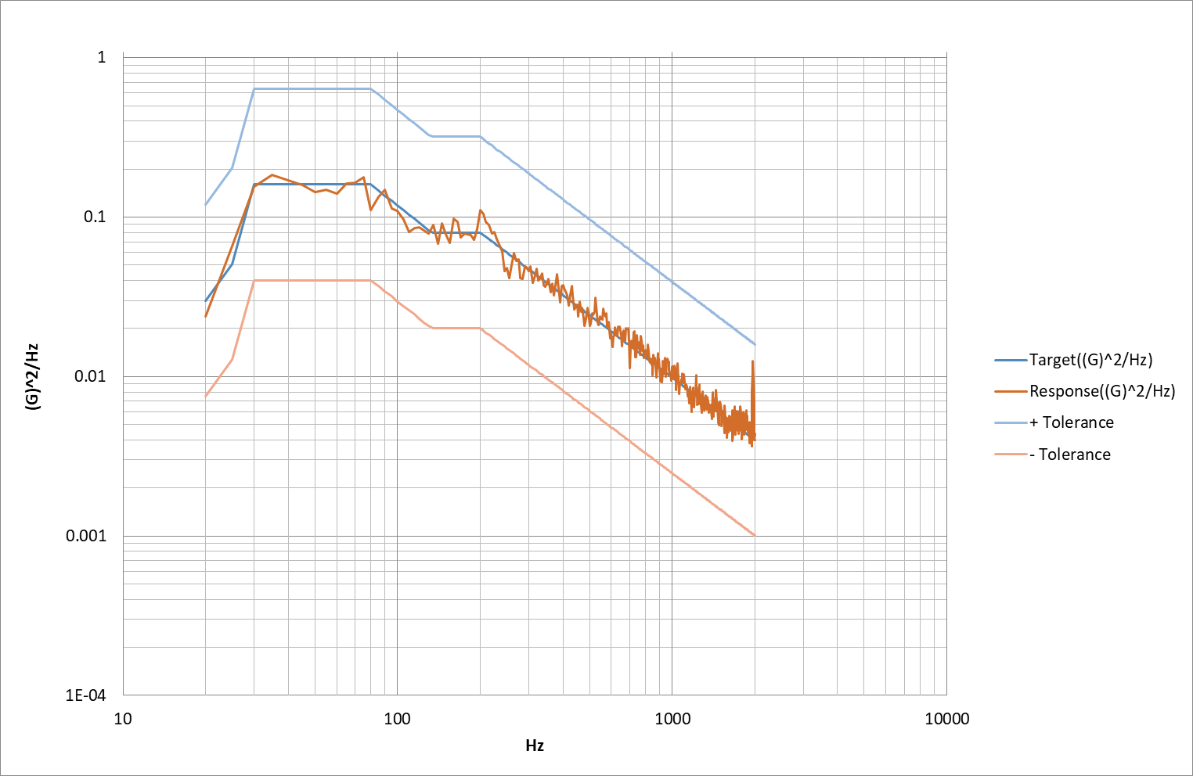

**Figure 7.2-1 Random vibration input profile on the X axis direction**

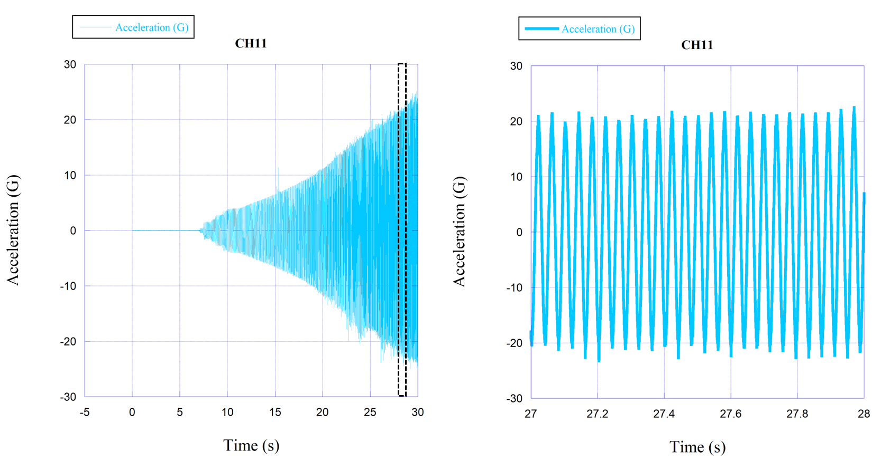

**(a) (b)**

**Figure 7.2-2 (a) Sine burst input profile on the X-axis direction and (b) 1 second window as wave form representative.**

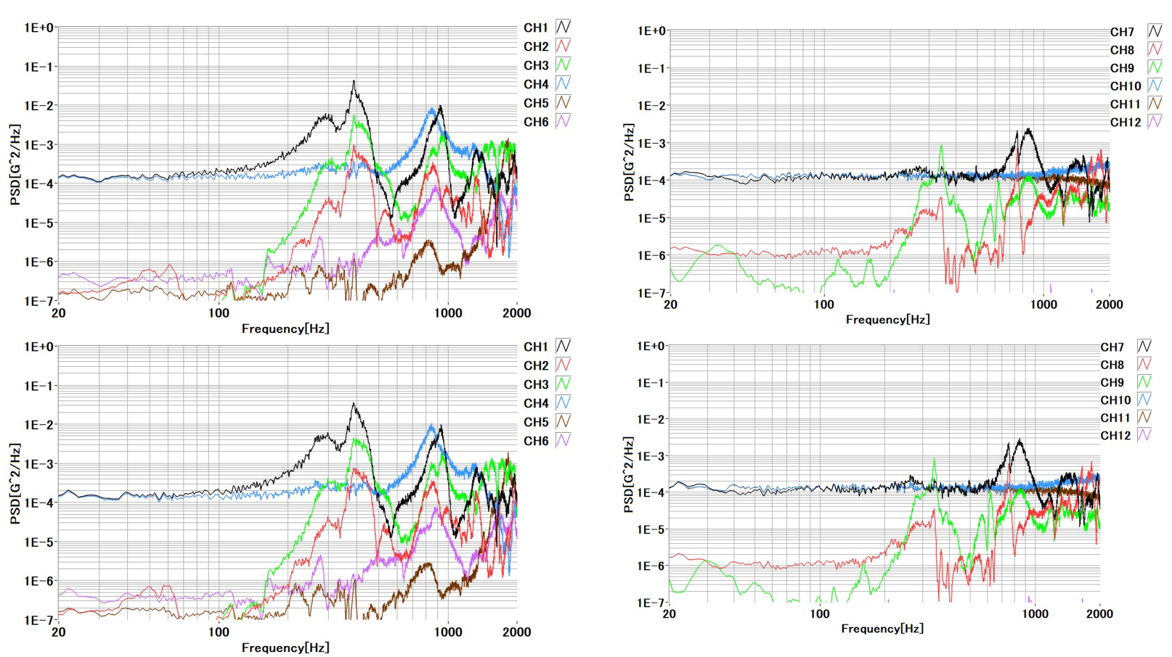

**Figure 7.2-3 Modal response before (top) and after (bottom) the random and sine burst test on X axis.**

In Figure 7.2-3, Ch1, Ch4, and Ch7 (black, blue on the left side and black on the right side, respectively) are the accelerometer on X axis. No major shift in frequency was observed.

## Results of Y axis

Figures 7.3-1 and 7.3-2 shows the actual random vibration and sine burst profile excited PSC at the QT level in the Y axis. The Ch 2 and 3 are the control reference.

**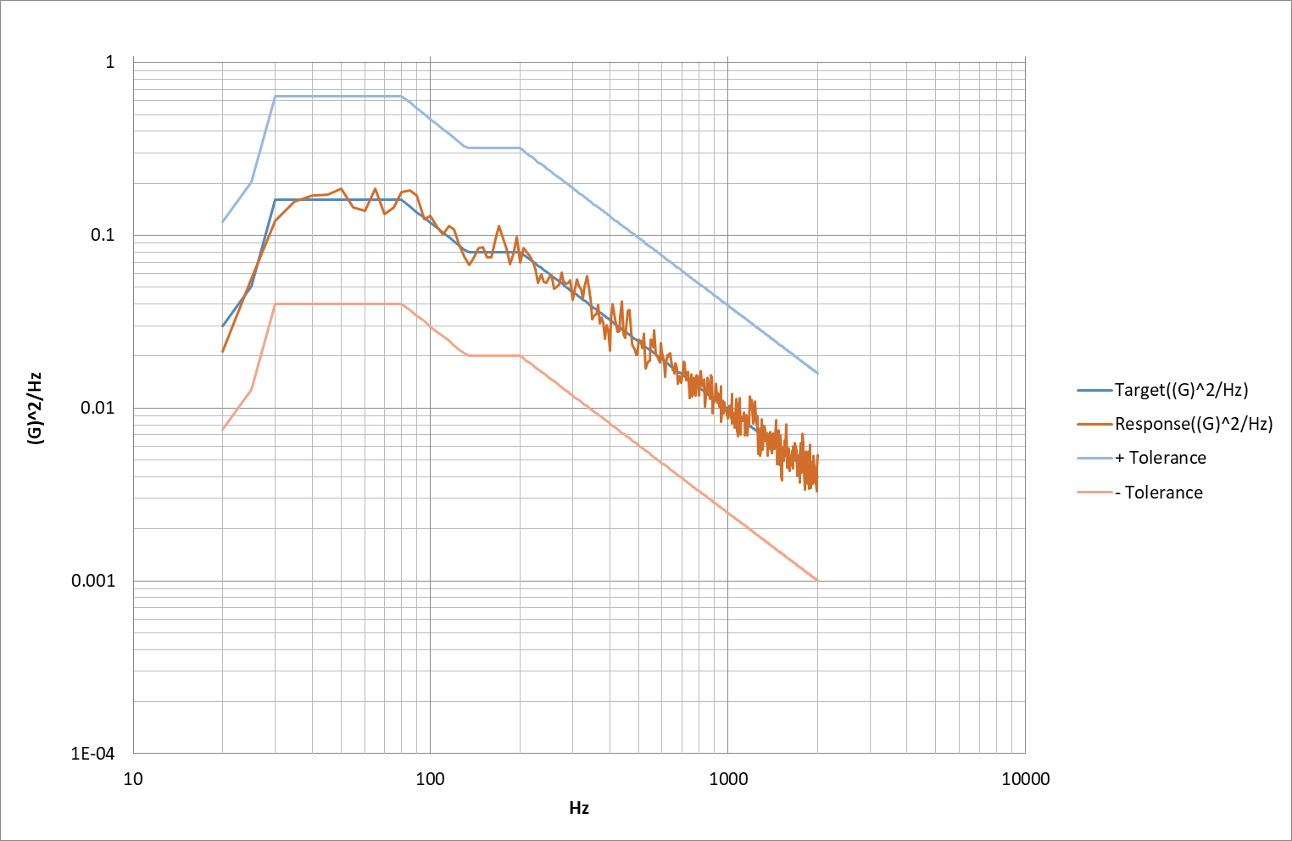**

**Figure 7.3-1 Random vibration input profile on the Y axis direction**

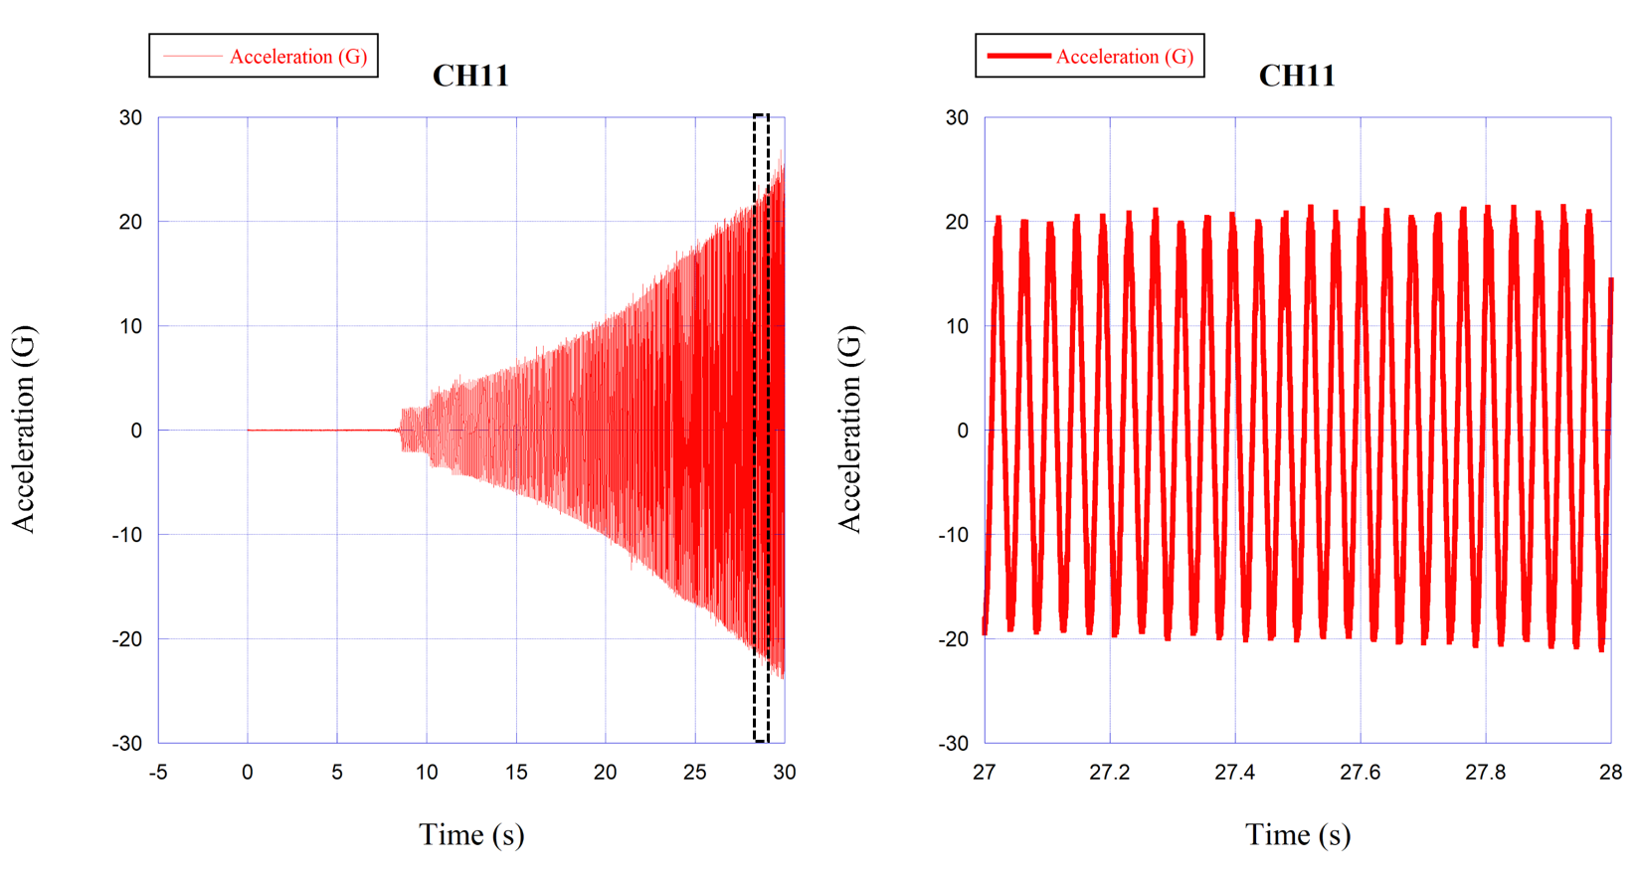

**(a) (b)**

**Figure 7.3-2 (a) Sine burst input profile on the Y-axis direction and (b) 1 second window as wave form representative.**

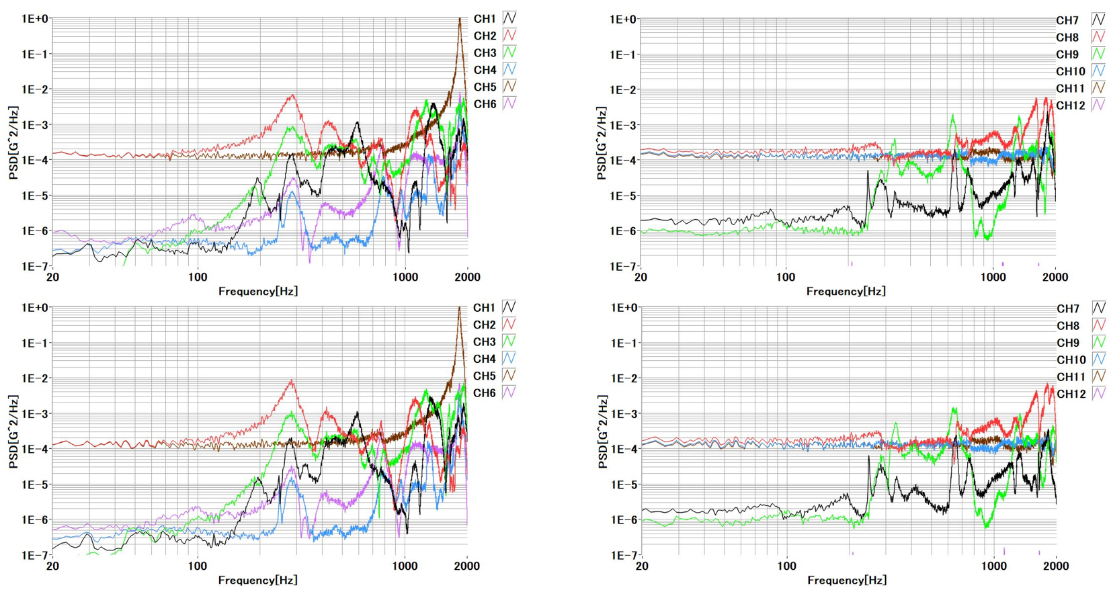

**Figure 7.3-3 Modal Response before and after the random and sine burst test on Y axis**

In Figure 7.3-3, the Ch 2, Ch 5, and Ch 9 (red, brown on the left side and green on the right side, respectively) is the accelerometer on Y-axis. No major shift in frequency was observed.



# **Summary of Results & Conclusion**

1. Deformation in the Main Structure: No deformation shall be observed in the inspections on the main frame before and after the test.

The test articles’ photos are taken before and after the vibration test for the risky materials in terms of deformation such as PEEK, FR4 and glass. Yet, no deformation is observed in any of these materials. Table 8-1 is showing the comparative photos.

**Table 8-1 Visual inspection on risky materials before and after the vibration test.**

|  |  |  |
| --- | --- | --- |
| Inspection Item | Before the Vibration Test | After the Vibration Test |
| +X Panel |  |  |
| -X Panel |  |  |
| +Y Panel |  |  |
| -Y Panel |  |  |
| +Z Panel |  |  |
| -Z Panel |  |  |
| Frame 1F – 1 |  |  |
| Frame 1F – 2 |  |  |
| Frame 3 | C:\Users\yibim\AppData\Local\Microsoft\Windows\INetCache\Content.Word\IMG_5724.jpg |  |

1. Shift in Natural Frequency: A significant shift in natural frequency indicates *workmanship failure* (loose components on/in the structure). Any broken parts in the primary structure shall be judged as a *failure in design.* The primary natural frequency shall be at least 100 Hz in X, Y, Z axes.

No major shift in frequency was observed and the primary natural frequencies were always higher than 100 Hz. However,

Table 9-1 Test Result

|  |  |  |
| --- | --- | --- |
| **Vibration** | **Satellite**  **Axis** | **Result** |
| X-axis | X-axis | No shift in frequency in Random and Sine Burst |
| Y-axis | Amplitude of natural frequency of higher than X-axis |
| Z-axis | No shift in frequency in Random and Sine Burst |
| Y-axis | X-axis | Slight shift in frequency in both Random and Sine Burst. Right shift corresponds to natural frequency increasing. This shows the test article was more compact than before |
| Y-axis | Slight shift in frequency in Random test however, the graph shifted back to original frequency after Sine Burst |
| Z-axis | No shift in frequency in Random and Sine Burst |
| Z-axis | X-axis | Slight shift in frequency in both Random and Sine Burst. Right shift corresponds to natural frequency increasing. This shows the test article was more compact than before |
| Y-axis | Amplitude of natural frequency of higher than Z-axis |
| Z-axis | No shift in frequency in Random and Sine Burst |

1. Torque Mark Shift: When observed visually, there should be no shift in torque marks on the screws on the test article after each test. Any shift in torque mark shows a *workmanship failure* in setting the required torque before testing.

No torque mark shift was observed.

1. Fracture Critical Parts:
   * All external fasteners and fasteners holding the main structure shall not be loose after vibration.
   * Glass components (including solar cells and camera lens) shall not be broken after vibration.
2. Deployable Components:

The deployable UHF & VHF dipole antennas shall not deploy during the vibration.

The antennas didn’t deploy during or after the test.

1. Satellite Function

Satellite functional test shall be conducted before and after vibration tests. Satellite should function the same after the vibration test as before the test.

Satellite function after vibration tests was the same as before tests.